SIMATS ENGINEERING
ASSESSMENT TOOL 3

COURSE NAME: Artificial Intelligence COURSE CODE: CSA17

COURSE OUTCOME COVERED

CO1: Apply AI basics such as intelligent agents and uninformed search methods to solve problems effectively. (BL3)

Assessment Tool Weightage: 30%

Duration : 45 Minutes
QUESTIONS: 2 Total Marks:20

Annexure A

Descriptive Written Test

Code of Conduct:

I _ALLU THANMAI (192412616)__ (Name / Reg No) certify that this submission is my original work and that I have adhered to the guidelines specified for this assessment.
I understand that any violation of academic integrity rules will result in disciplinary action.

Signature of the student:

ALLU THANMAI

Annexure A

Descriptive Written Test

- A smart home automation system is being designed to manage lighting, temperature, and security based on user behavior and environmental conditions. The system must respond to real-time inputs such as motion detection, temperature changes, and time of day while also learning user preferences over time. In this context, explain the different types of intelligent agents (simple reflex, model-based, goal-based, and utility-based agents) and analyze how each type would function within this system. Justify which type of agent or hybrid approach would be most effective for ensuring comfort, energy efficiency, and security.
Intelligent Agents in Smart Home Automation
Introduction
A smart home automation system uses intelligent agents to monitor the environment, understand user requirements, and take suitable actions. The system receives real-time inputs such as motion, temperature, light level, time of day, and security events. It can also learn the user's preferences over time.

The four important types of intelligent agents are:
Simple Reflex Agent
Model-Based Reflex Agent
Goal-Based Agent
Utility-Based Agent

1. Simple Reflex Agent
A simple reflex agent selects an action based only on the current percept. It follows condition-action rules.
Working in smart home:
Examples:

If motion is detected → turn ON the light.
If temperature > 28°C → turn ON the fan/AC.
If it is night → turn ON outdoor security lights.
If the door sensor detects unauthorized entry → activate alarm.

Advantages
Simple to design.
Fast response.
Requires less computation.

Disadvantages
Does not remember previous situations.
Cannot learn user preferences.
Cannot handle complex situations effectively.

Example:
If the user always prefers dim lighting at night, a simple reflex agent cannot learn this preference.

2. Model-Based Reflex Agent
A model-based agent maintains an internal state or model of the environment. It uses current inputs along with previous information.
Working in smart home:
For example, the system can remember:
Which rooms are occupied.
Current temperature.
Whether lights are already ON.
Previous security status.
Recent user activity.
If no motion is detected in a room for a long time, the agent can understand that the room is probably unoccupied and switch OFF the light.

Advantages
Can handle partially observable environments.
Maintains information about previous situations.
More intelligent than a simple reflex agent.

Disadvantages
Requires more memory.
More complex to design.
Does not necessarily choose the best action among multiple alternatives.

3. Goal-Based Agent
A goal-based agent chooses actions to achieve a specific goal.
Possible smart-home goals are:
Maintain comfortable temperature.
Reduce electricity consumption.
Keep the house secure.
Turn lights ON when required.

Ensure doors are locked when occupants leave.

Example
Suppose the goal is:
Reduce energy consumption while maintaining user comfort.
The agent may decide to:
Turn OFF unused lights.
Adjust AC temperature.
Use natural light during daytime.
Reduce heating/cooling when nobody is home.

Advantages
Works toward specific objectives.
Can consider future actions.
More flexible than reflex agents.

Disadvantages
May require search/planning.
A goal alone does not indicate which solution is better.

4. Utility-Based Agent
A utility-based agent selects the action that provides the highest overall utility or benefit.

In a smart home, utility can consider:
Comfort + Energy Efficiency + Security + Cost

For example, suppose the temperature is high and nobody is in the room. The agent has two choices:

Run AC continuously → high comfort but high energy consumption.
Turn AC OFF → saves energy but may reduce comfort when the user returns.

A utility-based agent can choose a balanced action, such as reducing AC operation and restoring the preferred temperature when the user is detected.

Advantages
Makes better decisions when multiple objectives conflict.
Can balance comfort, cost, energy and security.

Suitable for complex real-world environments.

Disadvantages
More difficult to design.
Requires a utility function.
Requires more computation and information.

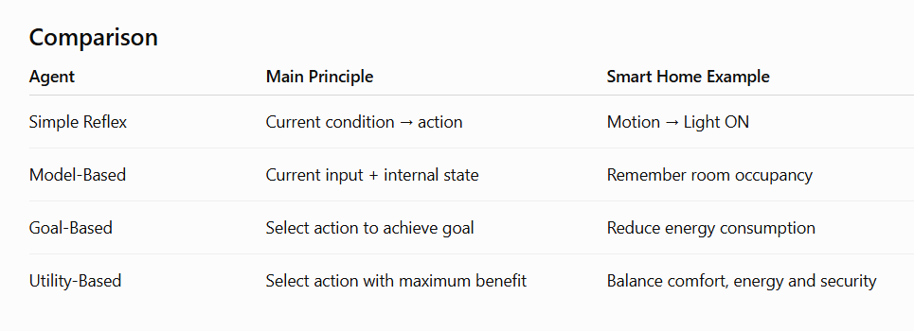
Best Agent for the Smart Home
The best approach is a hybrid agent, mainly using a utility-based + model-based + learning approach.

Proposed working:
Sensors → Model/Memory → Learning → Utility Evaluation → Action

For example:

Motion sensor detects the user.
System checks current temperature and time.
Internal model determines whether the room is occupied.
Learning component identifies the user's preferred temperature.
Utility function considers comfort, electricity consumption and security.
System selects the best action.

Why this is best
A single agent type cannot efficiently handle all smart-home requirements.
Simple reflex provides quick responses.
Model-based maintains environmental information.
Goal-based helps achieve specific objectives.
Utility-based balances conflicting requirements.

Learning allows the system to improve from user behavior.

Conclusion
Therefore, a hybrid utility-based and model-based intelligent agent with learning capability would be most effective. It can provide comfort, energy efficiency, security and personalized automation while adapting to changing user behavior.

Best exam line:

A hybrid utility-based agent with model-based memory and learning capability is most suitable because it can balance comfort, energy efficiency and security while adapting to user preferences.

- A robot is placed in an unknown maze and must find a path to the exit without prior knowledge of the layout. Explain how uninformed search strategies like Uniform Cost Search (UCS) and Iterative Deepening Search (IDS) can help solve this problem.
Discuss the advantages and disadvantages of these algorithms in terms of time and space complexity. Relate the problem to different types of intelligent agents and explain how agent design affects decision-making. Suggest which combination of agent type and search strategy would be most effective and justify your choice.

Robot in an Unknown Maze – UCS and IDS
Introduction
Consider a robot placed in an unknown maze. The robot does not know the complete layout beforehand and must find a path from the starting point to the exit.

The problem can be solved using uninformed search algorithms such as:

Uniform Cost Search (UCS)

Iterative Deepening Search (IDS)

These algorithms do not use domain-specific heuristic information.

A. Uniform Cost Search (UCS)
UCS expands the node having the lowest total path cost.

The evaluation is:

g(n)=cost from start to node n
The node with the smallest g(n) is expanded first.

Example
Suppose the robot has:

Start → A → B → Exit
with costs:

Start → A = 2
A → B = 3
B → Exit = 2
Total cost:

2+3+2=7
UCS continues exploring paths in increasing order of total cost until it reaches the goal.

UCS Procedure
Start from the initial position.

Add the start node to a priority queue.

Select the node with the lowest path cost.

Expand its neighboring positions.

Calculate their cumulative costs.

Add unexplored nodes to the priority queue.

Continue until the exit is reached.

Advantages of UCS
Complete when step costs are positive.

Finds the least-cost path.

Useful when different movements have different costs.

Disadvantages
Can consume large memory.

Can be slow if many paths have similar costs.

Priority queue management adds computational overhead.

Complexity
For branching factor b, optimal solution cost C
∗
, and minimum step cost ϵ:

B. Iterative Deepening Search (IDS)
IDS combines the advantages of Depth-First Search (DFS) and Breadth-First Search (BFS).

It performs depth-limited DFS repeatedly:

Depth=0, 1, 2, 3,…
until the goal is found.

Example
The robot first searches:

Depth 0 → Start
Then:

Depth 1 → Start + immediate neighbors
Then:

Depth 2 → nodes up to depth 2
Then:

Depth 3 → nodes up to depth 3
The process continues until the exit is found.

Advantages
Requires much less memory than BFS.

Complete for finite branching factor.

Finds the shallowest solution when all step costs are equal.

Useful when solution depth is unknown.

Disadvantages
Repeats the search from the beginning at every depth.

Can perform repeated node expansions.

Does not guarantee minimum cost when movement costs differ.

Complexity
Time:

O(b
d
)
Space:

O(bd)
where:

b = branching factor

d = depth of the shallowest solution.
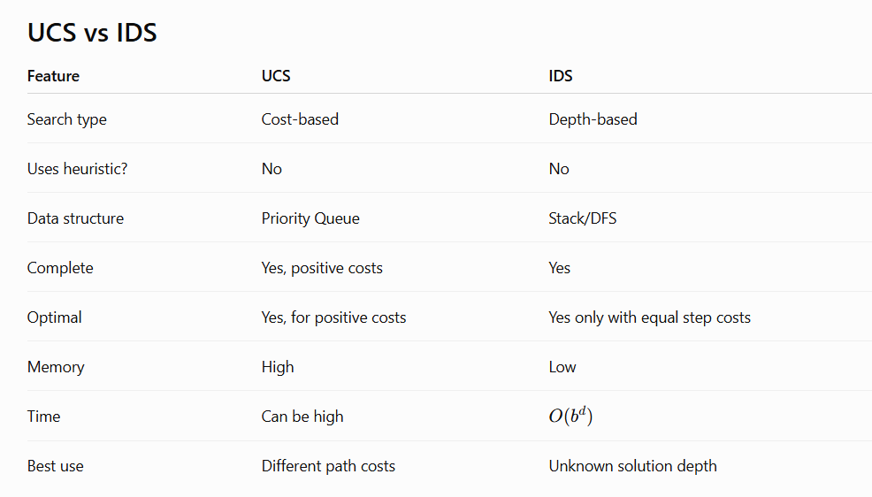

Intelligent Agent and Maze Problem
The robot can be designed using different types of intelligent agents.

1. Simple Reflex Agent
The robot reacts only to the current situation.

Example:

If obstacle is ahead → turn right.

Problem: It does not remember where it has already travelled, so it can get stuck in loops.

2. Model-Based Agent
The robot maintains an internal map of the maze.

It remembers:

Visited locations.

Obstacles discovered.

Available paths.

Current position.

This is much better for an unknown maze.

3. Goal-Based Agent
The robot has a specific goal:

Reach the exit.

It evaluates possible actions based on whether they help it reach the exit.

4. Utility-Based Agent
The robot can consider additional factors such as:

Shortest distance.

Lowest energy consumption.

Safest path.

Movement cost.

It selects the path providing the highest utility.

RUBRICS FOR CALCULATION:

Criteria | Weightage | Level 4 – Exemplary | Level 3 – Proficient | Level 2 – Developing | Level 1 – Beginning
Criteria | Level 4 (Exemplary) | Level 3 (Proficient) | Level 2 (Developing) | Level 1 (Beginning) | Max Marks
Understanding of Concepts | 25% | Demonstrates thorough, accurate understanding of concepts | Good understanding with minor gaps | Basic understanding with some misconceptions | Poor understanding; major misconceptions
Explanation | 25% | Detailed, well-explained answers with relevant examples | Clear explanation with adequate details | Limited explanation; lacks depth | Poor or unclear explanation
Application | 20% | Effectively applies concepts with strong analytical ability | Applies concepts with minor errors | Limited application with weak analysis | No application or incorrect analysis
Organization | 15% | Well-structured answers with logical flow and coherence | Organized with minor issues in flow | Basic structure, lacks clarity | Poor organization, incoherent answers
Accuracy | 10% | Completely accurate and covers all required points | Mostly accurate with minor omissions | Partially correct with missing points | Incorrect answers with major gaps
Clarity | 5% | Clear, neat, professional presentation | Understandable with minor issues | Limited clarity, readability issues | Poorly written, difficult to understand

